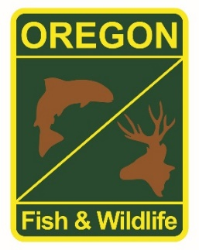

**State Fisheries Genomics Lab Tissue Sample Intake Form**

Please complete the top part of this form and send to: [kathleen.omalley@oregonstate.edu](mailto:kathleen.omalley@oregonstate.edu)

Make arrangements with us prior to dropping off the tissue samples and include a copy of this form with your samples.

**Project dropping off samples:**

Oregon Department of Fish and Wildlife; Lower Rogue District; Huntley Park

**Person dropping off samples:** Chris Stephens

**Phone:** Cell: 541-294-0561 **Email:** Christopher.L.Stephens@state.or.us

**Description of samples (e.g. species, collection locations, collection dates, collection methods, number of samples, life stage; may attach spreadsheet):**

Two sample boxes with 164 individual vials. Each vial contains 95% Ethanol and a caudal fin clip from an adult steelhead. Tissue samples were collected during the Huntley seining project on the Rogue River between mid-July and late-October.

**If applicable, known origin (e.g. natural or hatchery):**

All tissue samples are from natural origin fish.

**Sample type (e.g. fin tissue, scale, muscle, etc):**

Caudal fin tissue

**Storage method (e.g. dry, 95% ethanol, RNA later, etc):**

95% ethanol